FAL00100 – TAX TYPE LOOKUP

USER INTERFACE

INITIAL VERSION

BUTTON DEFINITION
Button Name | Action
OK | Run SELECT DATA PROCESS
Cancel | Close Form

INPUT PARAMETER
Parameter Name | Description
CCOMPANY_ID | Company Id
CSTATUS | Status, available values ALL, ACTIVE, INACTIVE
CTAX_TYPE_ID | Selected Tax Type ID
CLANGUAGE_ID | Language ID

OUTPUT PARAMETER
Parameter Name | Description
CTAX_TYPE_ID | Tax Type ID
CTAX_TYPE_NAME | Tax Type Name
CTAX_TYPE_ID_NAME | Tax Type ID and Name
CTAX_TYPE_DESC | Tax Type Description
IUSEFUL_LIFE | Useful Life in years
LACTIVE | Active Flag, 1=Active, 0=Inactive
CREC_ID | Record ID

INITIAL PROCESS
Test
- Run REFRESH PROCESS

DISPLAY PROCESS

FIELD DEFINITION
Name | Field | Type | Validation

DATA GRID DEFINITION
Name | Field | Type | Validation
Tax Type ID | CTAX_TYPE_ID | Label
Tax Type Name | CTAX_TYPE_NAME | Label
Useful Life (Year) | IUSEFUL_LIFE | Label
Active | LACTIVE | Checkbox
Description | CTAX_TYPE_DESC | Label
Grid Mode
- Read Only

BUTTON MODE
Button Name | Mode
OK | IF Grid not empty THEN Enabled ELSE Disabled
Cancel | Enabled

REFRESH PROCESS

VALIDATION
Field | Condition | Validation Message

ACTION
- Refresh Data Grid with RSP_FAL00100_TAX_TYPE with parameters
  - CCOMPANY_ID
  - CSTATUS
  - CTAX_TYPE_ID
  - CLANGUAGE_ID
- IF Grid empty,
  - Display message “No data found!”

SELECT DATA PROCESS

VALIDATION
Field | Condition | Validation Message

ACTION
- Return selected row info to caller program

FAL00200 – TAX CATEGORY LOOKUP

USER INTERFACE

INITIAL VERSION

BUTTON DEFINITION
Button Name | Action
OK | Run SELECT DATA PROCESS
Cancel | Close Form

INPUT PARAMETER
Parameter Name | Description
CCOMPANY_ID | Company Id
CSTATUS | Status, available values ALL, ACTIVE, INACTIVE
CTAX_CATEGORY_ID | Selected Tax Category ID
CLANGUAGE_ID | Language ID

OUTPUT PARAMETER
Parameter Name | Description
CTAX_CATEGORY_ID | Tax Category ID
CTAX_CATEGORY_NAME | Tax Category Name
CTAX_CATEGORY_ID_NAME | Tax Category ID Name
CTAX_CATEGORY_DESC | Tax Category Description
CTAX_TYPE_ID | Tax Type ID
CTAX_TYPE_NAME | Tax Type Name
CTAX_TYPE_ID_NAME | Tax Type ID and Name
IUSEFUL_LIFE | Useful Life in years
LACTIVE | Active Flag, 1=Active, 0=Inactive
CREC_ID | Record ID

INITIAL PROCESS
Test
- Run REFRESH PROCESS

DISPLAY PROCESS

FIELD DEFINITION
Name | Field | Type | Validation

DATA GRID DEFINITION
Name | Field | Type | Validation
Tax Category ID | CTAX_CATEGORY_ID | Label
Tax Category Name | CTAX_CATEGORY_NAME | Label
Tax Type Name | CTAX_TYPE_NAME | Label
Useful Life (Year) | IUSEFUL_LIFE | Label
Active | LACTIVE | Checkbox
Description | CTAX_CATEGORY_DESC | Label
Grid Mode
- Read Only

BUTTON MODE
Button Name | Mode
OK | IF Grid not empty THEN Enabled ELSE Disabled
Cancel | Enabled

REFRESH PROCESS

VALIDATION
Field | Condition | Validation Message

ACTION
- Refresh Data Grid with RSP_FAL00100 with parameters
  - CCOMPANY_ID
  - CSTATUS
  - CTAX_TYPE_ID
  - CLANGUAGE_ID
- IF Grid empty,
  - Display message “No data found!”

SELECT DATA PROCESS

VALIDATION
Field | Condition | Validation Message

ACTION
- Return selected row info to caller program

CR LIST

CR | Description | Notes
00  04-Nov-2025 | - INITIAL VERSION
 |  | </CR2>
 |  | </CR5>

TEMPLATE

VALIDATION
Field | Condition | Validation Message

ACTION

CR LIST

XXXXXXX - TEMPLATE

USER INTERFACE

INITIAL VERSION
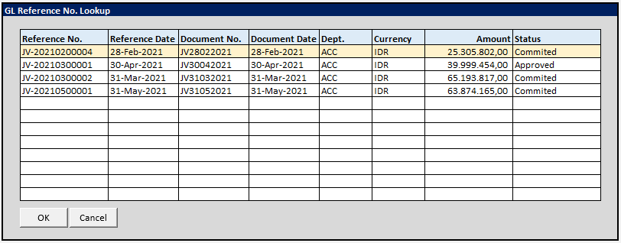

BUTTON DEFINITION
Button Name | Action
OK | Jalankan SELECT DATA PROCESS
Cancel | Tutup Form

INPUT PARAMETER
Parameter Name | Description
CUSER_ID | Login user id
CCOMPANY_ID | Company Id
CTRANS_CODE | Transaction Code
CPERIOD | Journal Period dengan format YYYYMM
CLANGUAGE | Login User’s profile language ID

INITIAL PROCESS
Test
- Refresh REFERENCE NO. Grid dengan RSP_GL_GET_REFERENCE_NO_LOOKUP dengan parameter
  - CUSER_ID
  - CCOMPANY_ID
  - CTRANS_CODE
  - CPERIOD
  - CLANGUAGE_ID

DISPLAY PROCESS

FIELD DEFINITION
Name | Field | Type | Validation

REFERENCE NO. GRID DEFINITION
Name | Field | Type | Validation
Reference No. | CREF_NO | Hidden
Reference Date | CREF_DATE | Label
Document No. | CDOC_NO | Label
Document Date | CDOC_DATE | Label
Dept. | CDEPT_CODE | Checkbox
Currency | CCURRENCY | Label
Amount | NTRANS_AMOUNT | Label
Status | CSTATUS_NAME | Label
Grid Mode
- Read Only

BUTTON MODE
Button Name | Mode
OK | IF Grid not empty THEN Enabled ELSE Disabled
Cancel | Enabled

SELECT DATA PROCESS

VALIDATION
Field | Condition | Validation Message

ACTION
- Return informasi berikut dari selected row ke form pemanggil

